How Does the Use of the Daily 5 Structure

Influence Reading Scores of ELL Students?

Tamara R. Yackel

A thesis
submitted in partial fulfillment of the
requirements for the degree of

Master of Education in Curriculum and Instruction
with an emphasis on Language, Literacy and Culture

University of Washington
2009

Program Authorized to Offer Degree:
College of Education

Table of Contents

Page

Purpose of Project…………………………………………….1
Rationale of Project…………………………………………...2
Literature Review……………………………………………..3
Procedure……………………………………………………..11
Case Studies…………………………………………………..16
Conclusion……………………………………………………46
Bibliography………………………………………………….50

i

Purpose

The purpose of the project was to find an approach that taught literacy to my ELL students based on current research practices. According to Krashen (2004), literacy is the ability to read and write. This project examines how the Daily 5 (Boushey & Moser, 2006) provides literacy strategies that are successful with ELL students. The Daily 5 is a structure that allows me to meet with small groups while my other students are engaged in sound literacy practices. In this paper I will be discussing the rationale behind the project, the procedure of carrying out the project, the relevant literature for the project, specific case studies and a conclusion of how the project was analyzed.
The acquisition of this knowledge equipped me to better meet the needs of my diverse classroom of students. I was able to plan and implement individual or small group lessons while my other students were engaged in the activities of the Daily 5. ELL students need specific strategies to help them build fluency and comprehension in reading. In addition, research (Echevarria, Vogt, & Short, 2004) clearly indicates that ELL students need practice with the language processes of listening, reading, writing and speaking.
The five activities that my students work on address all four of the language processes that ELL students need to grow and develop. English Language Learners come from a variety of backgrounds and literacy levels. In order for me to meet all the needs of my learners, I need to meet with small groups to teach specific skills.
Case studies were used to examine the effect of using the Daily 5 structure and the fluctuation of reading scores. The background, reading scores, and anecdotal records were kept on six middle school students in an ELL classroom. The primary teacher analyzed the information to see if the use of the Daily 5 structure had a measurable effect on the students’ reading scores.

Rationale
Kent School District 415 has a large ELL population with 130 different languages. In my own classroom I encountered a diverse group of students with many different languages. This project originated out the researcher’s interest to study an effective means to deliver high quality instruction while every student was engaged in literacy activities.
What structure would allow me to teach in small groups and to individuals while other students were practicing their literacy skills? Given the great differences in my students, I really needed to come up with a way to teach all of my students the skills they needed. I had gone to a Daily 5 workshop in August of 2008. I continued to research the effectiveness of the Daily 5 and found that the principles of the structure were based on strong literacy practices. The Daily 5 provided me time to meet with individual students, assess their needs, and teach them specific skills to develop their literacy independence.
The research population included six students of varied literacy levels and backgrounds in Kent, Washington. Two of the students had previous formal schooling whereas four of the students were refugees from different countries. The research study included student background information, reading scores, and anecdotal records. In order to research the effectiveness of the Daily 5 I relied upon a review of sound literacy practices among an ELL population.

Literature Review
The Daily 5 is a structure and not a curriculum. The Daily 5 has been used in general education classrooms in the Kent School District 415. Gail Boushey (2006) the author of the structure has taught this method at her elementary school. Some of the general education classrooms that use the Daily 5 have ELL learners in that classroom.
In order to have more concrete evidence about the use of the Daily 5 I have interviewed the author of the book, Gail Boushey (2006). Some countries have adopted the Daily 5 as their structure for reading. Thailand and Malaysia have adopted this system ( Boushey, & Moser, 2006) in their respective school districts. In addition, some International Schools such as the Province of Quebec ( Boushey, & Moser, 2006) are using the Daily 5 structure. There has not been research as of yet of the Daily 5 structure used in ELL classrooms. However, the Daily 5 has strong research based instruction practices and focuses on improving a child’s independent reading, writing and comprehension.
Based on the strong research associated with the Daily 5 and the other literature that I have reviewed, I have adopted this structure in my classroom. I am choosing this structure as opposed to other literacy structures because of the flexibility it offers.

Independent Reading and the Daily 5
First, the Daily 5 provides time for independent reading. Teachers who use “best practices (Zemelman, Daniels, &Hyde, 1998 ) are providing kids” independent reading practice.” ELL students need to have an opportunity to read for pleasure. The focus of the work by Krashen (2004) emphasized that ELL students who experience “pleasant” independent reading experiences develop at a “higher cognitive” rate . In addition, “reading is the only way we become good readers” (Krashen, 2004).When second language learners develop competence they are able to study literature. Reading for pleasure can be done in an independent setting at school or at home. Research (Krashen, 2004) indicates that when ELL students read for pleasure they improve in their second language without teachers, classes, or people to talk to.
When an ELL student is able to read with accuracy, fluency, and comprehension they become an independent reader. An independent reader can be more motivated and obtain reading success. Reading success according to Echevarria, Vogt, and Short (2004) is obtained through many opportunities and time to read. Hence, independent reading promotes increased literacy development among ELL students.

Reading With Someone and the Daily 5
Secondly, the Daily 5 structure provides students an opportunity to read with a partner. The research on ELL students and literacy indicates that kids can learn from each other (Echevarria, et al., 2004). In particular, ELL students will benefit from reading with someone. Even if the students have different levels of language acquisition the students can read together. A stronger English speaker may be paired with a brand-new speaker and together they can work out reading the words.
In addition, research shows that providing ELL students with predictable texts (Echevarria, et al., 2004) helps them to develop their literacy skills in English. Reading with someone allows a student to pick a book that has been read aloud, or that one partner has read already. Thus, the students will be comfortable reading the text because they have either read it or heard the story before. ELL students need to have choice. Choice is an important factor in motivation. If an ELL student can choose a partner, and they can negotiate what book to read, they are more likely to practice reading. Finally, in the act of choosing a friend and reading with them a lot of language is used. Clearly, talking and discussing books will enhance an ELL student’s oral language and literacy skills.

Listening to Stories and the Daily 5
In addition, reading at an early level requires ELL students to listen to the language. Listening is an important aspect of language acquisition
(Boushey & Moser, 2006). Listening to stories on tapes, compact discs and on the computer provides one way for ELL students to hear the English Language. Research indicates that listening to stories in English is an “effective way to develop fluency and confidence.” (Echevarria, et al., 2004).The Daily 5 provides an opportunity for students to listen to stories. The research I have reviewed regarding listening to stories is powerful.
ELL students need to have predictable texts. Predictable texts have helped ELL students develop fluency, accuracy, and comprehension in English (Boushey & Moser, 2006). I have found that predictable texts that I have read aloud are widely available on compact discs, tapes, or online. In addition, in my experience teaching in the classroom, my students loved to listen to stories on compact discs that I had read aloud to them. The familiarity of a story helps the student feel successful while he or she is listening to the story. Finally, I think that listening to a story helps build a student’s self-confidence. ELL students needs to feel that they can “do” something and are successful.

Word Work, Independent Writing and the Daily 5
Word work also provides students a chance to use their listening and speaking skills. ELL students need practice with word patterns, word sorts, phonics, and spelling. Word work is a way for an ELL student to practice many forms of words. The literature I reviewed demonstrates that ELL students “need a great deal of practice to reliably distinguish letters of the alphabet.” (Gambrell, Morrow, and Pressley, 2007). Therefore, within the Daily 5 of word work there are opportunities for beginning students to practice the alphabet. Word work can take a variety of forms. Students can practice words with blends, words with the silent e, irregular words, and words with common spelling patterns to name a few.
Word work helps develop an ELL student in their writing ability. Research shows (Echevarria, et al., 2004) that if ELL students are given many opportunities to work at their own pace, choose their own topic, and not be forced to be at the same level as their peers, their writing improves. ELL students who are given opportunities to have independent writing time such as journals, free write, or writer’s workshop develop stronger writing skills. ELL students gain control over language when they learn to write.
The best part of independent writing is that there is not the pressure that every piece of work is being graded and assessed. Many pieces that students write are for pleasure and practice. Clearly, research (Cunningham & Allington, 1999) indicates that students who enjoy writing will write more and develop strong language skills in both reading and writing. As referenced by (Echevarria, et al., 2004) “students can interact with the teachers through dialogue journals or pen pals. Journal writing provides a means for students to communicate and practice the language.
Another component of independent writing is that students are allowed to share their writing with the class. No one is ever forced to share, but all are encouraged to share. ELL students greatly benefit from being able to share their writing. ELL students need to practice their speaking skills, as well as reading in front of a group. In my own classroom research, I have found that “sharing” is a powerful tool among my ELL students. They love to share about their weekend, their family, and their lives.
ELL students need a lot of time to practice writing and motivation to write. My research on independent writing and word work confirms my belief that the Daily 5 will help develop writing and spelling among an ELL population.

Small Groups and the Daily 5
Finally, in my literature review, I researched the use of small groups with ELL students. Research shows that ELL students must develop “deep and broad oral vocabulary” in order to access meanings of words (Gambrell et al., 2007). Small group work during the Daily 5 can involve the use of explicit vocabulary instruction.
Clearly, ELL students need to be taught specific reading strategies, taught how to use graphic organizers to aid in comprehension, and given opportunities to interact with peers in many group situations. ELL students need different strategies based upon their current literacy level, background knowledge, and learning styles. As suggested,

English Learners need systematic, high-quality literacy instruction from the start that includes opportunities to read, write about, discuss and listen to literature. (Echevarria et al., 2004, p. 162)
The Daily 5 allows me to work with small groups of students on a variety of skills. Many of my students are refugees and have had little or no reading instruction. According to Echevarria et al., (2004) ELL students who have little previous schooling will “need more direct, small group or individual instruction.” In addition, some students have not developed phonological awareness.
ELL students “need to develop phonological awareness.” (Gambrell et al, 2007). Therefore, students can be taught phonological awareness in a small group setting. Research also shows (Krashen, 2004) that ELL students gain a better understanding of comprehensible input when they are taught specific reading strategies in a small group. Small group work or independent goal setting helps an ELL student achieve success in specific, targeted goals and strategies for reading and writing.

Procedure
In the fall of 2008, I began with a group of beginning ELL students. Most of my students were brand new to the United States of America. A few of my students came during 2007, but still were not reading English. I decided to keep track of my students through anecdotal records, examples of work, individual reading inventories, and data collection.
Prior to starting the study, I talked with my students and compiled an idea of what the students were interested in, and what they thought about reading. Research has shown that (Krashen, 2004) kids should read about topics that interest them.

In my classroom, I made sure that I had books that my students would be interested in. I encouraged my students to read books that they liked or were interested in. Many of my students enjoyed books about animals, comics, and graphic novels. Therefore, I had those books readily available for my students.
Each month I completed an individual reading inventory on each of my students. I recorded the level of text the student could read, the fluency rate at that level, and the comprehension rate at that level. In addition to the formal data, I also talked with my students throughout the study to see how they felt about their reading progress. I took anecdotal records to keep track of the conversations I had with my students. I would make notes about a student sounding out words, being stuck on a particular sound, or problems with comprehension of a text. Over the course of the school year, I was able to gather substantial information on the progress of my beginning ELL class.
Some of my students had been exposed to English prior to coming to the United States while other students had not even been in school before. In an attempt to explain the project in depth, I have included the child’s country of origin so that one can see the various cultures that were present during the project.
In order for my students to gain the best possible success in reading, I made it a point to have my students engaged in “active reading” on a daily basis. I think that “active reading” for the purpose of this project means that the student was reading the words. The teacher was not reading for the child, nor did the teacher interrupt the child to correct his/her reading. In my classroom, I allowed students to practice reading independently each day. My students had many opportunities to select the texts they read. During independent reading time students are allowed to choose books from my classroom library, their home, or the school library.
Some of my students chose to read graphic novels, some enjoyed picture books, and some wanted to read Junie B. Jones chapter books. In addition, my students chose to work with partners and read together during the Daily 5. As partners, students negotiated what books they would read and how long. My students were allowed to make mistakes and learn each day. In order to achieve this goal with a diverse classroom of many levels of readers, I had to be creative in the execution of this plan.
Based on the work by Gail Boushey and Joan Moser (2006) and my research of relevant literature I have adopted the Daily 5 in my classroom. This system is a form of Reader’s Workshop. I wanted to be able to work with small groups of students each day. I had to teach all of my students to be independent and to be able to do a literacy activity while I was working with a group of students. I taught my students five independent literacy activities that they could work on and be accountable for.
While my students were engaged in one of the five activities, I worked with small groups of students on reading. My assistant helped me during this time to facilitate all of the reading groups. My assistant worked with a group of four to five students. While she was teaching her group, I also worked with a small group of students for guided reading lessons. My other students could:
- read independently
- listen to reading
- read with someone
- work on writing
- word work
At the beginning of the year, I taught my students explicitly how to do each of the five activities. I modeled the activities numerous times and we practiced how to each of the five choices. Each day I would decide which group I would work with. My assistant would also decide which group of students she would work with.
I made a list on the white board that stated the five choices. I asked the students which choice they would be working on that day and wrote it down. Students would be dismissed to work on their reading choices. My assistant and I spent 20 – 30 minutes working on guided reading. In the guided reading groups we would work on sounding out words, looking at pictures, comprehension strategies, and vocabulary. We were able to work with two to three groups of students each day. I tried to pull my students into the guided reading groups each day so that I could teach them strategies for reading and have them practice reading with me.
I used a variety of materials to teach my students reading. I used library books, www.readinga-z.com, chapter books, and picture books. I tried to pick books and materials that the students were interested in. My students loved animals, science, and funny chapter books. I learned about my students by talking with them during reading conferences. During the reading conferences, I would find out what kind of books they liked, what was funny to them, and their general topics of interest.
I would pull my students each month and complete the individual reading record. I met with each student one on one. I recorded their fluency rate and their comprehension rate at that time. I recorded the date of the reading and put it on a spreadsheet. I collected this formal data in order to see the progress of each of my students.
I also collected reading work, and anecdotal records throughout the project to get an idea of what my students thought and to see progress in different forms and genres. In addition to the individual reading inventories and anecdotal records, my students completed classroom based assessments. I used the classroom based assessments to check the comprehension level of my ELL students. I used a variety of observational, formal and summative assessments to figure out the level of the student.

Case Studies
I used data, background and information from six of my ELL students because they had attended my class since September of 2008. I chose this group of students as opposed to others because I knew them better, had more information, and had collected data on them. In the case studies, I was able to see the progress the Daily 5 had made in the student’s literacy growth. Again, the Daily 5 allowed me to teach individuals and small groups while the others were practicing sound literacy activities. The use of the Daily 5 structure increased my student’s fluency scores. Some students also progressed in comprehension.

Ben
14 year old boy from Kenya

Ben was born in Kenya. He came to the United States in 2007. According to his dad, the student demonstrated that he was fluent in his first language by reading, writing, and speaking in Swahili. The father did not have exact literacy scores from the refugee camp and was not sure if he was at grade level. Ben came to me as a very sad boy. His mother had died of a disease along with his four brothers, and one sister. Leaving his country proved to be difficult for this child. Of all things he left behind, he missed his cat the most. Ben was not able to speak, read, or write in English when he came to the United States.
Ben had gone to school at a refugee camp his whole life and was not exposed to English. The social aspect of a middle school was shocking for Ben. He did not know how to interact with his peers, had trouble getting along with others, and was not used to sitting in a classroom. Not only did he have the academic life to worry about, he also was suffering from the loss of his family. Learning to read and write in English was the last thing on this child’s mind.
Slowly, Ben and I began to learn from each other. When he saw that I was here to teach him and that I cared about him, he started to learn. He began with learning the letters of the alphabet, then progressed to sight words, and is now reading. I am astounded by the progress Ben has made. He is able to read at a 3rd grade level. The constant practice of reading made Ben focus and get better. Although, we do not know his exact literacy level in his first language it is known that he can read, write, and speak Swahili. He is also able to speak and understand Somali, but cannot read or write in Somali.
Ben has learned social vocabulary very quickly and can tell stories. Slowly, he is acquiring academic language. Academic language ( Chamot & O’Malley, 1994) is much harder to acquire. In addition, he is learning academic vocabulary in a middle school when he can only read and write at a third grade level. In middle school, students have to go to different classes all day long and are not in one classroom for the day. He has had to go to Social Studies, Science and Math along with ELL classes.
Ben can read sight words fluently, sound out words, and answer literal questions about a story. He can tell you what the story is about, who the characters are and what the setting is. Considering the hardships he has endured, I feel that he is making substantial progress.
Ben has made considerable progress even though he had limited formal schooling in a refugee camp. In September the student was reading at a Pre-Primer level at 85% fluency. I did not test comprehension the first month of school. By October, the student was reading with 95% accuracy at a Primer Level. In October, Ben was able to comprehend 75% of the text. In November, the student read at grade level 1 with 94% accuracy. The comprehension at level 1 was 87.5%. The student continued to read at grade level 1 with an increase to 96% accuracy. The student remained stable with an 87.5% comprehension rate. In January, Ben increased the reading level to grade 2 with an accuracy rate of 89%. The comprehension rate at grade 2 was 87.5%. Ben finished the year strong in May by reading with a 94% fluency rate at the third grade level. At the third grade level his comprehension was 70%.
To gain a better understanding of my students, I interviewed them about their interests in reading. I think that Ben generally wanted to learn English and please the teacher. He said that he enjoyed reading funny stories, comics, and books about animals. He especially loved stories about cats. During the year, he was able to pick stories that interested him and I tried to provide material at his level.
During the Daily 5, I was able to work with Ben on decoding strategies, and sounding out words. The anecdotal records from Ben told me that he could sound out beginning words. In addition, when he read aloud to me, I was able to ask him what the story was about. In general, he was able to answer literal questions.
When I tested Ben on the individual reading records, he grasped the main idea of a story and who the main character was. During the year, he steadily increased his comprehension scores.
Ben’s fluency was being slowed down by trouble with blends such as “cr”, “fr”, and “ch”. In an individual reading conference, I was able to show him how to blend the letters to sound out the word. Then, I would give him a goal of sounding out the blends as he was reading. Ben was able to practice this skill during two parts of the Daily 5. I had him work on his goals during independent reading time and reading with someone.
Throughout the study Ben’s reading level improved. He was able to improve each month. I think fluency rate improved because he practiced the reading goals I had set for him during the Daily 5 structure. In addition, he has been in the United States approximately one year longer than the other students that were in the study.

Table 1
Ben
Country of Origin: Kenya
Age: 14 years old

Month | Reading Level | Fluency | Comprehension
September | PP | 85% | n/a
October | P | 95% | 75%
November | 1 | 94% | 87.5%
December | 1 | 96% | 87.5%
January | 2 | 89% | 87.5%
February | 1 | 97% | 62.5%
March | 2 | 95% | 75%
April | 3 | 92% | 70%
May | 3 | 94% | 70%

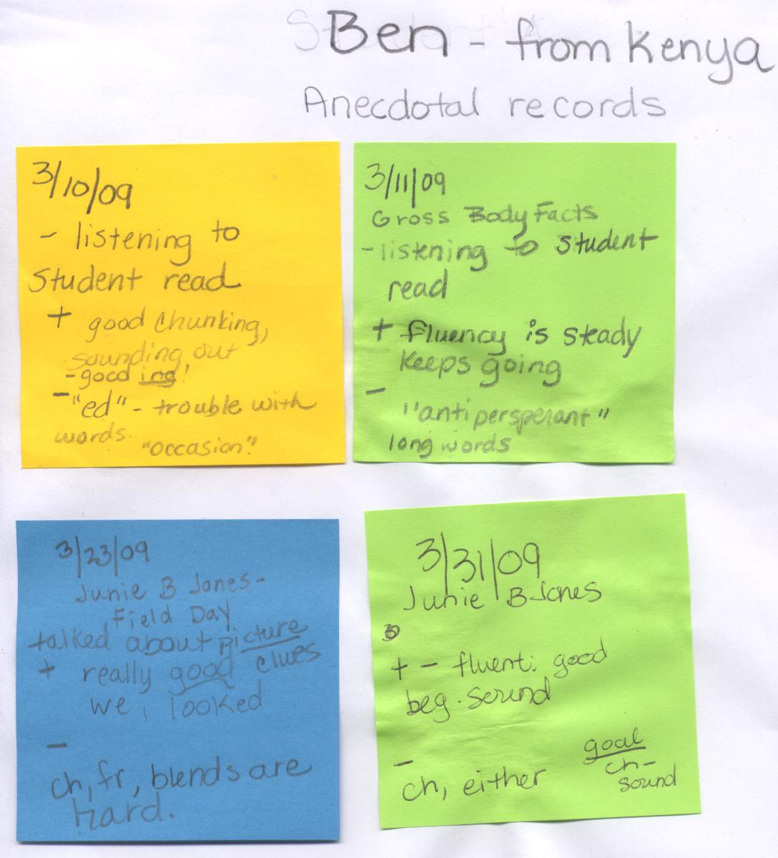

John
12 year old boy from Russia
John is a seventh grade boy in my classroom. He is Turkish, but was born in Russia. He came to this country in 2005 with his family. The family came to the United States because of the conflicts between the Turkish and Russian people. John can read, write, speak and listen in Russian according to his parents. However, his parents were not able to tell me if he was at grade level. They said that he could read, and write but they did not have his exact literacy level scores. In addition, because of where he grew up, he can speak and listen in Turkish. John attended school in Russia at the age of six. He had no prior training in English. John is a beginning ELL student in my classroom. Currently, he is reading at a second grade level.
I am a bit surprised that he is still reading at the second grade level since he has been here since 2005. He started school at an elementary where he was pulled out for English Language instruction. Research indicates that ELL pull-out programs are not the best way to teach English Language Learners (Zehr, 2006; Brandts, 1999). I am wondering if his previous pull-out experiences had a negative impact on his ability to make meaning from print. He was in an ELL pull-out program for two years. Sometimes ELL pull-out programs take students away from core academic subjects and this could have impacted his reading skills.
Now, he is in middle school. In middle school, students are not pulled out of classes to learn English. Students are put into a class that teaches English along with reading and writing. It appeared to me that John had not been taught to read with independence nor had practiced the skill for a long period of time. I have noticed that with his continued practice in reading, his fluency and comprehension have improved.
In the beginning of the year, John was reading at a Pre-primer level with 95% accuracy. By October, he had moved up to a Primer level with 95% accuracy and 87.5% comprehension rate. As you can see from table 2 his progress has been slow but steady. In January, February, and March he remained reading fluently at the first grade level. However, his comprehension at that level improved from 62.5% in December to 75% comprehension rate in March. By May, John could read with a fluency rate of 94% and a comprehension rate of 50% at the second grade level.
Why is John’s progress so slow? There could be many reasons why John did not progress as rapidly as others. However, I think that my inability to access his first language, his previous pull-out in ELL, and his inability to achieve stamina had some effect on his slow progress. It is unknown whether John missed some critical reading instruction during his pull-out in ELL. However, given that he was in the program for two years, it is likely that he missed some guided reading instruction.
Research (Gibbons, & Cummins, 2002) shows that students who are unable to access their “L1 literacy skills” are more frustrated and have low literacy levels. Also, he could have had trouble with comprehension because his background knowledge or schema did not “match the culture for which the text was written” (Echevarria, et al., 2004). In other words, it is very hard for someone to read a story, let alone understand it, if you have no previous experience with the topics or words in the text.
John loved to read with someone during the Daily 5. Although his independent reading was not progressing as quickly as others, his fluency definitely improved from the beginning of the year. His daily reading practice did help improve his decoding skills and resulted in higher fluency scores.

Table 2
John
Country of Origin: Russia
Student Age: 12 years old

Month | Reading Level | Fluency | Comprehension
September | PP | 95% | n/a
October | P | 95% | 87.5%
November | P | 99% | 62.5%
December | 1 | 95% | 62.5%
January | 1 | 97% | 75%
February | 1 | 99% | 62.5%
March | 1 | 99% | 75%
April | 1 | 97% | 62.5%
May | 2 | 94% | 50%

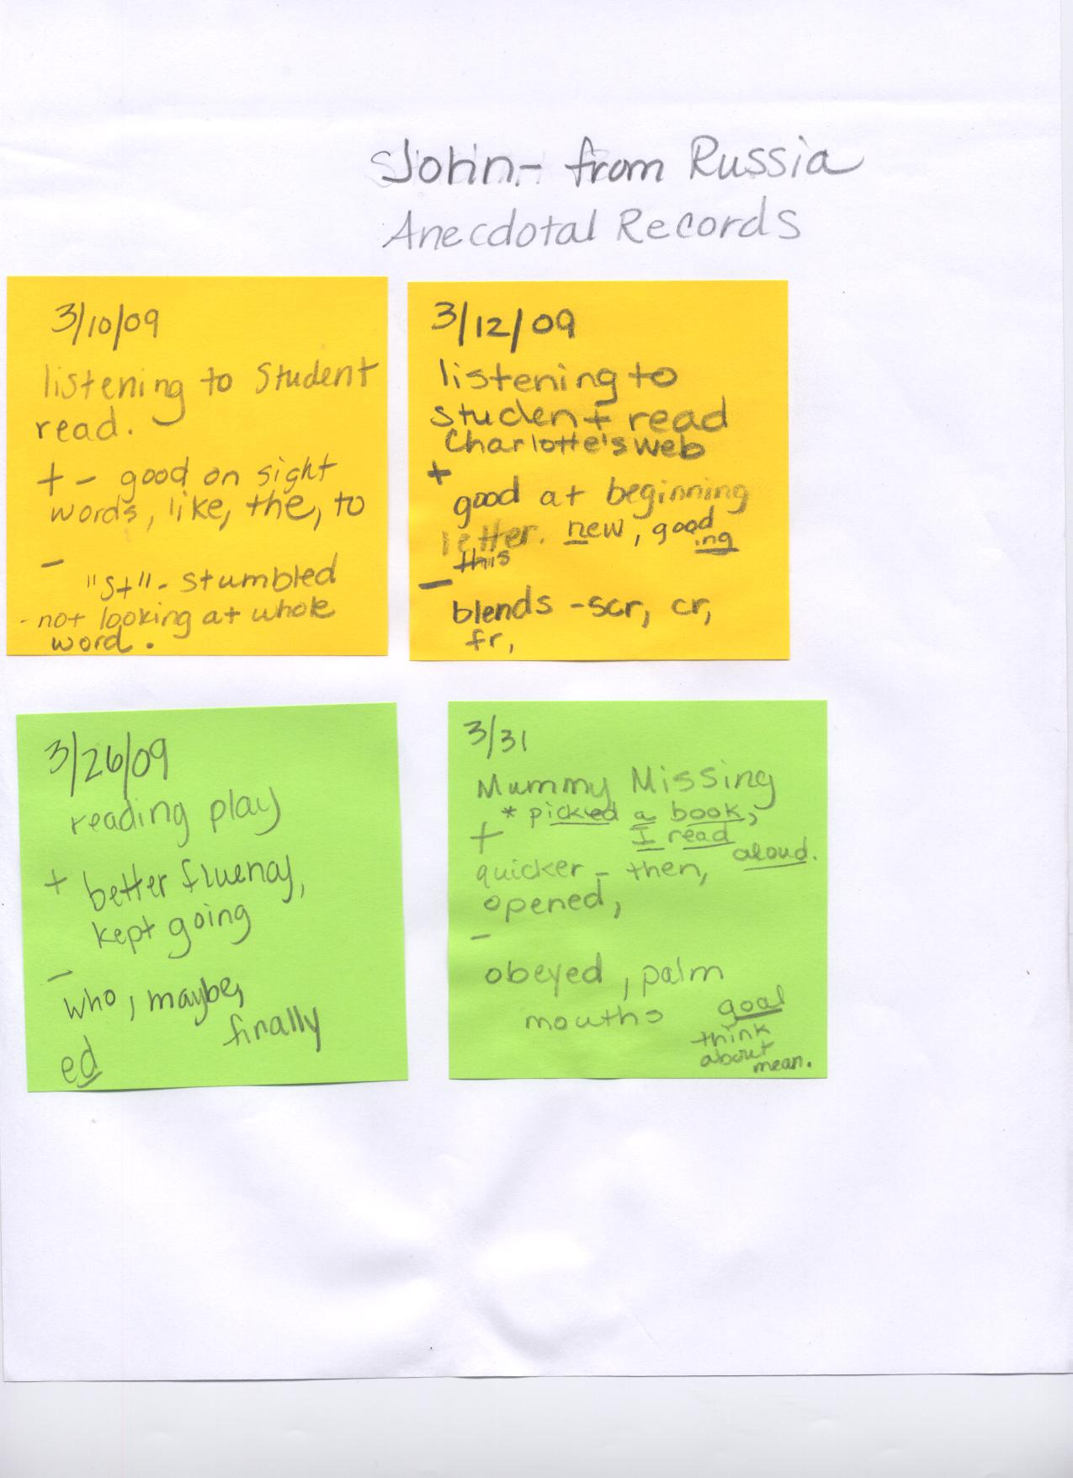

Bill
14 year old boy from Burma
Bill was born in India. As a young child he moved to Burma. He has spent most of his life in a refugee camp. Bill began school at approximately five years old. He can speak in Chin although he cannot read and write in Chin. Bill can speak, write, read and listen in Burmese as discussed with his father at parent teacher conferences in November of 2008. He had no prior English instruction at the refugee camp. His family wanted better opportunities so they came to the United States. Bill has been in the United States since September of 2008.
Bill has made good progress and is reading at a first grade level. He is able to read sight words fluently. As I was conducting anecdotal records, I found out that he has trouble with blends and endings in words. We continue to work on reading strategies and mini-lessons to help him learn to read.
Bill’s fluency and comprehension showed vast improvement over the course of the study. In September, he was reading at a Pre-primer level with 85% fluency. By the end of the study he was reading at a first grade level with a 96% fluency rate. A student who has not developed literacy in his first language (Krashen, 2004; Cummins, 1994) will have a harder time acquiring a second language. By May, Bill had a fluency rate of 100% and a comprehension rate of 75% at the first grade level.
Bill’s low comprehension rate could be attributed to many factors. According to his parents, he had not developed literacy in his first language (Krashen, 2004; Cummins, 1994) and I was not able to provide instruction in his home language. He did not have any access to his L1 literacy skills (Gibbons & Cummins, 2002). Students that can only access English during instruction seem to have slower acquisition rates of literacy in English (Gibbons & Cummins, 2002).
Bill’s family came from difficult socioeconomic conditions and different cultural values which could have affected his rate of comprehension. Another factor for Bill could have been that he could not access his “background knowledge” which is the “basis for understanding and learning” ( Echevarria, et al., 2004). However, Bill was not reading or speaking when he came to my classroom. Therefore, I think the progress was good.
Bill had intense small group instruction during the Daily 5. His increased fluency rate can be attributed to direct instruction on sounding out words, breaking words into chunks and looking at word endings.

Table 3
Bill
Country of Origin: Burma
Student Age: 13 years old

Month | Reading Level | Fluency | Comprehension
September | PP | 85% | n/a
October | PP | 89% | 0%
November | PP | 92% | 50%
December | PP | 92% | 62.5%
January | PP | 95% | 87.5%
February | 1 | 97% | 25%
March | 1 | 93% | 37.5%
April | 1 | 96% | 50%
May | 1 | 100% | 75%

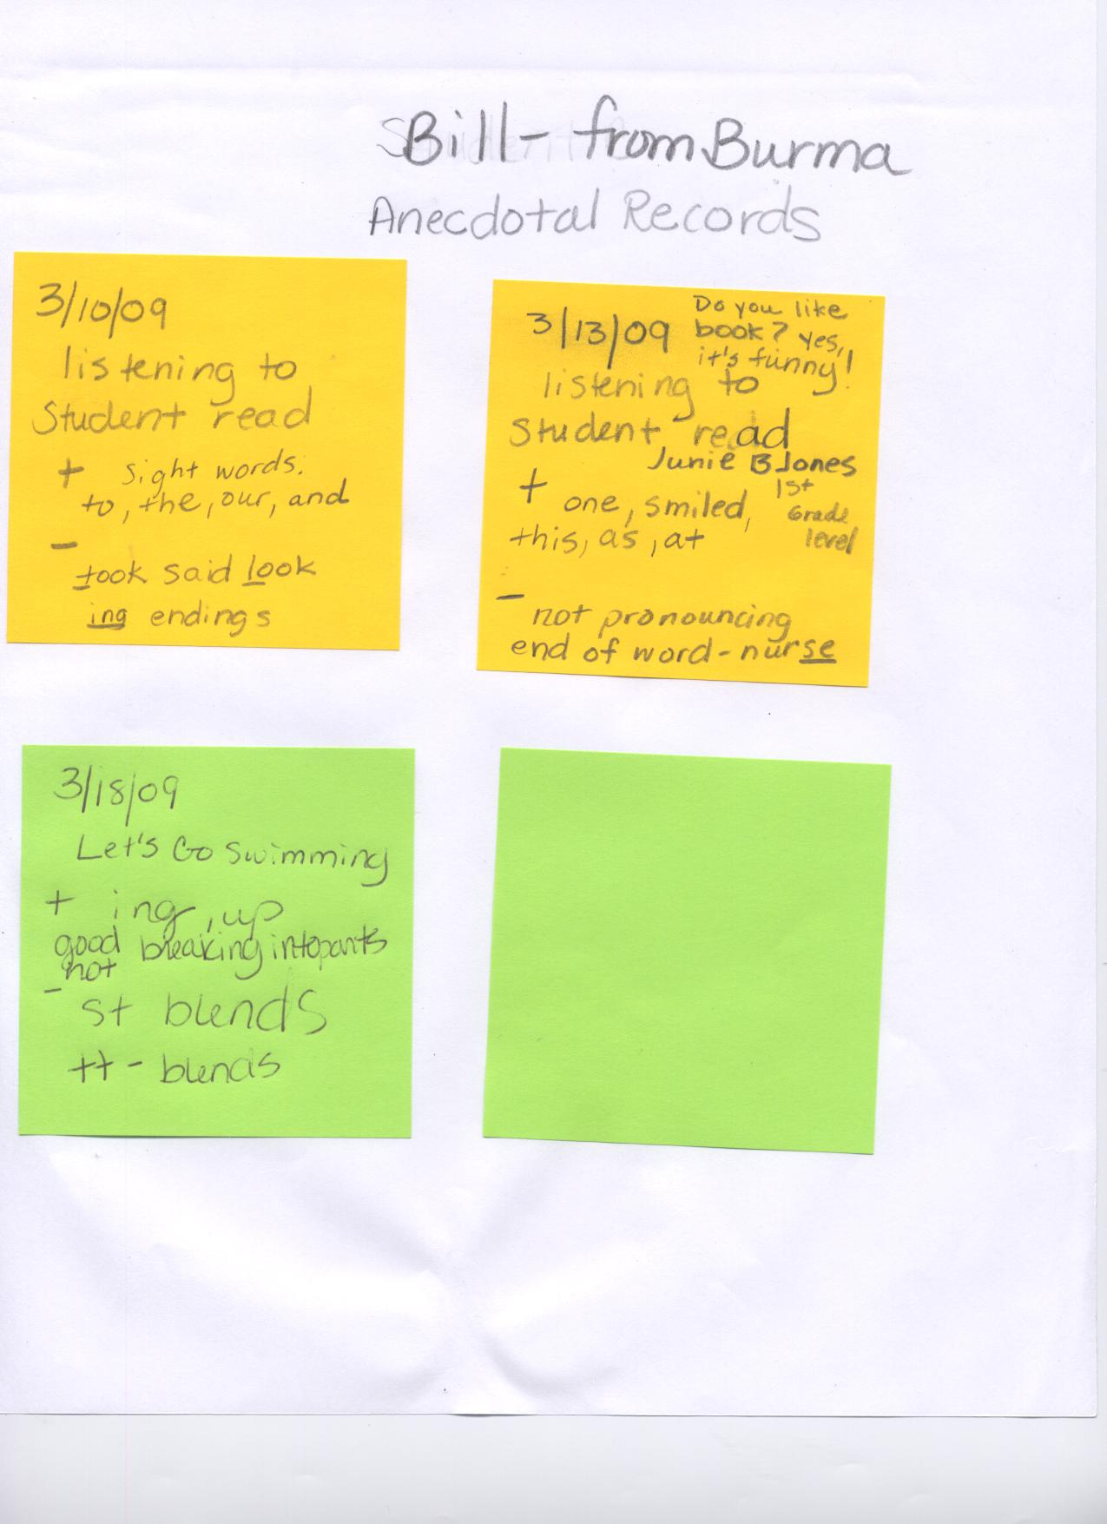

Jill
14 year old girl from Ukraine
Jill came to the United States in January of 2008. She was born in Ukraine and began school in Ukraine at 6 years old. Jill’s first language is Ukrainian. Her parents confirm that she can read, write, listen and speak in Ukrainian. According to Jill, Ukrainian and Russian are very similar and she can also speak, read, write, and listen in Russian. Jill’s parents told me that she was a good student and was at grade level in her first language. Research clearly indicates that “knowledge of first language structure” helps students with making “connections with the English language” ( Echevarria, et al., 2004). When she was in 5th grade she did attend some English classes. She learned some basic vocabulary words in English.
Her family came to the United States for jobs and better opportunities. Sadly, Jill reported to me that her family often went without food in Ukraine. Sometimes they only had bread to eat. In fact, she said that she has become “plump”, from having enough food to eat here in the United States.
Jill has made quick progress. She is reading at a third grade level. I think her prior instruction in English helped her to learn words quickly. She was able to access more background knowledge (Chamot & O’Malley, 1994; Moustafa & Maldono-Colon, 1999) than other students.
In the case of Jill she had prior English instruction and had formal schooling in Ukraine. In September, she was reading at a Primer level with 99% fluency. By October, she had jumped to reading at a first grade level with 100% accuracy and 87.5% on her comprehension rate. She continued to progress each month and is currently reading at a third grade level with 100% fluency. Her rate of comprehension at the third grade level was at 70%. By May, Jill had increased her comprehension rate to 80% at the third grade level and remained accurate with a rate of 100% fluency.
Jill likes reading. She especially likes books about animals, and mysteries. She loved the A –Z mysteries that I shared with her. I provided her with books at her level, allowed her time to read, and let her go. She was a student that did not need prompting to read independently. When I made a suggestion that she write down words on post-its that she didn’t know, she took it and ran with it. You could give her a suggestion or coach her in literacy and she grabbed on to it.
The Daily 5 allowed me to teach Jill how to progress her literacy to a higher level. I was able to provide her with chapter books that interested her and that she was able to read. In addition, I was able to teach her how to use context clues to figure out what words she did not know. When a child has a broader vocabulary base, (Krashen, 2004) there comprehension will improve.

Table 4
Jill
Country of Origin: Ukraine
Student Age: 14 years old

Month | Reading Level | Fluency | Comprehension
September | P | 99% | n/a
October | 1 | 100% | 87.5%
November | 2 | 99% | 75%
December | 2 | 98% | 87.5%
January | 2 | 95% | 100%
February | 3 | 100% | 70%
March | 3 | 100% | 70%
April | 3 | 100% | 80%
May | 3 | 100% | 80%

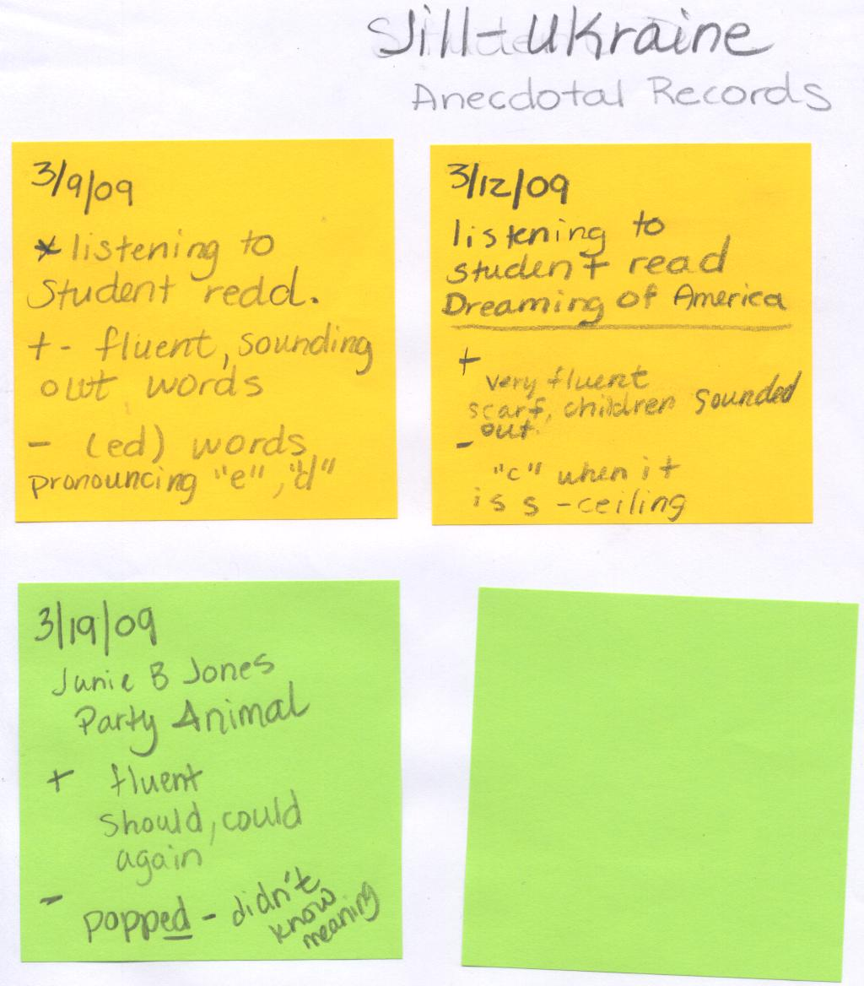

Marie
13 year old girl from Burma
Marie was born in Burma and moved to Thailand when she was very young. Her background includes most of her life surviving in a refugee camp. In this culture, she was exposed to a bit of the Thai language. She can understand a little bit of Thai. However, her parents have told me that her first language is Karen. She can read, speak, write and listen in Karen which is a dialect of Burmese. She was at grade level in her first language according to her father. Marie came to the United States in May of 2008. She is a tender hearted girl with a determined attitude. In Thailand, she was exposed to a little bit of English.
Only knowing a little bit of English was hard for Marie when she came to this country. Her parents came here for a good education and a better job. Sometimes she is overwhelmed from leaving her friends and family. She often is sad and misses her friends.
Being sad has not stopped this young lady! She is currently reading at a second grade level and practices each day. Her ability to read and write in her first language has helped her acquire English as a second language. Research (Krashen, 2004; Cummins, 1994) indicates that students who are literate in their first language will acquire the second language more rapidly. She wants to learn English even though it is hard for her. Marie confessed to me that she would like to be a nurse or a teacher so that she will be able to take care of her parents when she is older. I think she is well on her way to succeeding in whatever she does.
A determined student can progress rapidly. Marie proved to demonstrate progress with her fluency and comprehension. In September, she was reading at a Primer level at 95% fluency. By October, she had moved up to a first grade level with 90% accuracy and 75% comprehension. By March, she was reading at a second grade level with a fluency rate of 93% and a comprehension rate of 87.5%. By the end of the study, Marie was reading at a 2nd grade level with a 100% fluency rate and a 87.5% rate of comprehension.
Throughout the study, Marie was really reading and trying. She went to tutoring at my school every Tuesday and Thursday. Her parents are extremely supportive and studies show that “school persistence”
(Strekalova & Hoot, 2008) results in positive “attainment of refugee children.” They come to school events and parent conferences. In addition, the parents wanted her to achieve success and be happy. Marie also went to the refugee center at night to study English. She tried to absorb as much language as she could. Her progress has been remarkable. Her writing is amazing! She will sit for a whole hour and write independently. Marie was given ample opportunity to practice independent writing during the Daily 5 and that has developed her enjoyment of writing. Her love of writing, paired with her constant reading practice during independent reading time has resulted in very good literacy progress for this child.

Table 5
Marie
Country of Origin: Burma
Student Age: 13 years old

Month | Reading Level | Fluency | Comprehension
September | P | 95% | n/a
October | 1 | 90% | 75%
November | P | 96% | 75%
December | 2 | 93% | 87.5%
January | 2 | 96% | 87.5%
February | 2 | 95% | 87.5%
March | 2 | 93% | 87.5%
April | 2 | 94% | 75%
May | 2 | 100% | 87.5%

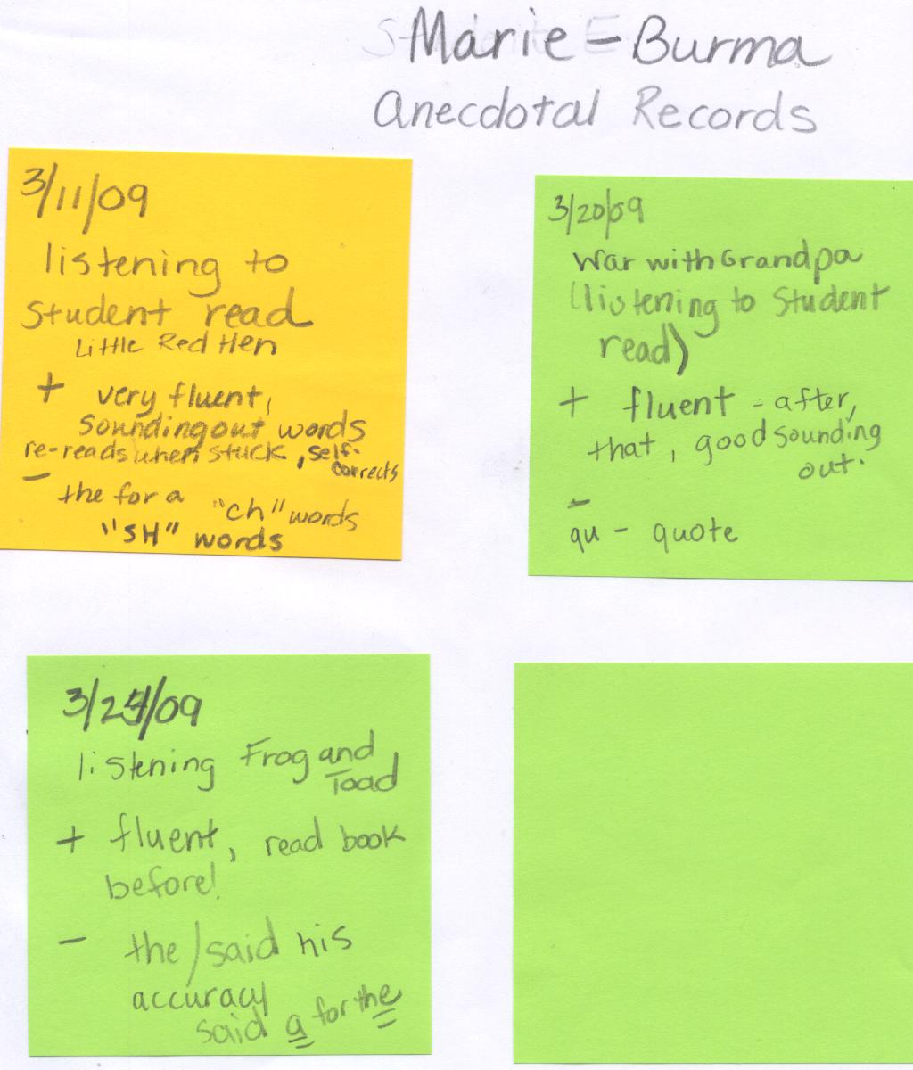

Scott
14 year old boy from Nepal
Scott came to the United States in September of 2008. He was born in Nepal and attended school in Nepal. His first language is Nepali and he is fluent in reading, writing, listening and speaking Nepali. His mother said that he was able to read and write in his first language, but that they were concerned that he might have some mental disabilities. They were not sure his exact level of literacy in his first language. His father speaks Hindi and he is able to speak a little bit of Hindi.
Scott has a visual impairment. He is not able to see print that is too small. In addition, I received some paperwork from Nepal that claimed he was “mentally retarded.” He was tested in Nepal and was labeled in that country as having a severe learning disability. Not knowing what I am dealing with has been difficult. Currently, Scott is being evaluated by a series of professionals to see exactly what the issues are. He is seeing an eye specialist, a neurologist, and psychologist to determine, if any, the extent of any learning disabilities.
The fact that Scott was not speaking or looking at me when he first started school with me really concerned me. However, he has now progressed and is reading at a second grade level. He responds to me, looks at me, and is able to carry on social conversations. I am sure the shock of coming to a new culture had some effect on this child. His parents wanted a better job in the United States and Scott was not sure about moving. He had some English classes in Nepal at a refugee camp.
The refugee camp can be a rough place according to Scott. He would tell me stories of the teacher slapping him and hitting him with a ruler. Fortunately, he is safe with me and likes learning in America. He is happy now about being in America and thinks school is “good.”
Scott’s reading scores proved to be a bit confusing. However, in March it was discovered by an eye doctor that he had a “wandering” eye. Although he could see, this wandering eye caused him sometimes to lack depth perception. His low comprehension scores could have been attributed to his frequent absences and the unknown effects of the eye problem.
There was no way for me to know exactly what he saw on the page. He often had to bring the book really close to him to read. I could have him read aloud and get a general idea of what he was seeing. But the extent of the medical problem related to his reading ability is not known at this time. He had surgery at the end of April to correct the wandering eye. We will have to see as the year progresses whether the surgery has improved his literacy progress.
At the beginning of the year he was not speaking at all. I was not able to get him to even name a letter for me. By October, he was reading at a Pre-Primer level with a fluency rate of 99% and a comprehension rate of 37.5%. Throughout the study, comprehension proved to be the most difficult part for this student. In December, he was reading at a Primer level with a fluency rate of 99% and a comprehension rate of 62.5%. Currently he is able to read at a second grade level with a fluency rate of 100% and a comprehension level of only 25%. Scott is able to decode words, but he does not focus on the meaning of the words. I am still working with him on thinking about what he is reading and teaching him vocabulary that he needs to understand the text.
Scott’s schooling in a refugee camp could have had an effect on his literacy skills. Students with “limited formal schooling will be pre-literate or have low literacy” (Freeman, Y., Freeman, D., & Mercuri, S., 2001) due to their “interruptions in schooling.” Some refugee children
“have difficulty concentrating on school work.” (Strekalova & Hoot, 2008) Refugees might be distracted because of language and post-traumatic stress. Scott could have been distracted because of his inability to fully understand the language or a traumatic event in his home country. Another reason for Scott’s low progress could be my inability to help him “access his literacy skills in his first language” (Gibbons, & Cummins, 2002).
In the analysis of Scott’s comprehension rate, I must also consider the fact that he had surgery, moved to another school, and had a new ELL teacher in April. His different scores or lack of progress could be attributed to the fact that the move and surgery caused him to be absent from school. I had another teacher do the individual reading inventory in March, April and May because he was not in my classroom. Anytime that you have another teacher evaluating scores there can be discrepancies in the meaning of the scores.
Although his scores fluctuated, he made substantial progress from not speaking to decoding at a 2nd grade level. I attribute the progress to the use of the Daily 5 structure. In particular, Scott loved to listen to predictable stories. Listening to predictable stories helps children acquire English.
In addition, to his individual work in the Daily 5 structure, I was able to work with him one-to-one to focus him on comprehending what he read. When I coached him, he was able to follow the story better, use predictions and identify characters. Had I not had the Daily 5 structure set in my classroom, I may have not been able to teach this child one-to-one.

Table 6
Scott
Country of Origin: Nepal
Student Age: 14 years old

Month | Reading Level | Fluency | Comprehension
September | Not speaking | 0% | n/a
October | PP | 99% | 37.5%
November | P | 99% | 50%
December | P | 99% | 62.5%
January | 2 | 99% | 50%
February | 2 | 98% | 37.5%
March | 2 | 99% | 25%
April | 2 | 99% | 25%
May | 2 | 100% | 25%

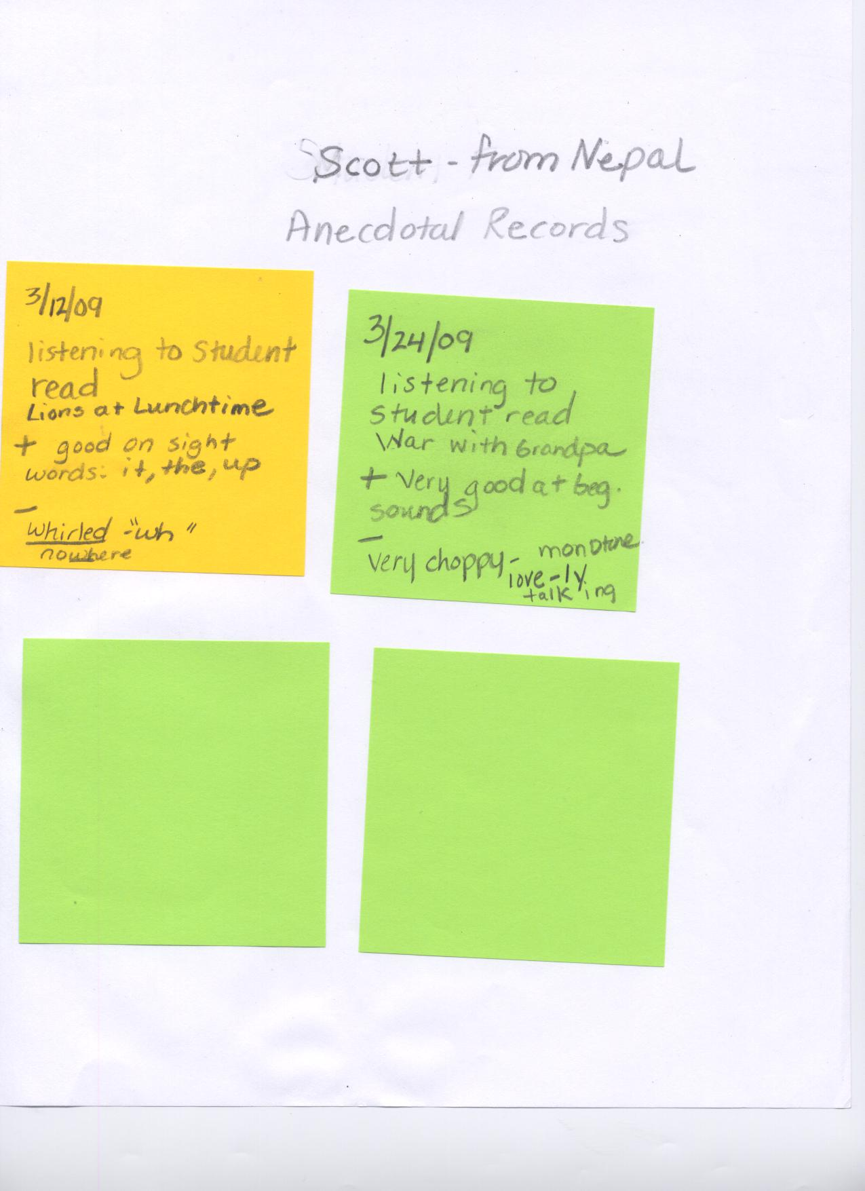

Conclusion

Summary of the Case Studies

During the process of this project all of my students improved their reading skills. All of my students increased their fluency rates. The continued literacy practice during the Daily 5 structure has helped my students in developing stronger accuracy rates in oral reading scores.
A significant fact in my studies was that I was not able to access or help anyone with their first language. Unfortunately, due to the number of languages in my class, I was not able to get materials in other languages. Since the students could not access their first language their comprehension scores were not progressing as fast as I had hoped. In addition, “knowledge of other languages can lead learners to make incorrect guesses at how the second language works ( Gibbons, and Cummins, 2002).
John was the only student who had previous experience in an ELL pull-out program. As previously indicated, the pull-out program can have a detrimental effect on second language acquisition (Zehr, 2006; Brandts, 1999).
Some students made significant progress whereas some students made minimal progress. Students were given the opportunity to practice reading everyday and that enhanced their progress. Students achieved success at different rates. I think motivation, practice at home, and prior experiences influenced the outcome of the student’s reading progress. For instance, Jill who had formal schooling had a significantly higher fluency scores and comprehension levels. Jill also had strong parental support, and was motivated.
The Daily 5 Structure helped me to meet the needs of my students. My students needed different skills at different times. Some students such as Bill really needed strategies to sound out words, and blends. The Daily 5 allowed me to teach him that strategy, set a goal for him and then practice that goal within the Daily 5 structure.
Learning to read requires a complex set of skills. I learned a lot about my students as I read with them, took anecdotal records, and reading inventories. I learned what my students had trouble with, what I needed to teach them, and how to drive my instruction to meet the needs of my learners. The anecdotal records proved to be the best way for me to evaluate my students. When I was reading and talking with my students one to one, I was able to see specific strategies they were using or not using, what words they had trouble with, and what stories they were interested in.
The Daily 5 provided me time to work with small groups, or one on one. In addition to allowing me to work with small groups of students the Daily 5 structure clearly influenced my fluency scores. The practice of independent reading, listening to reading, reading with someone, word work and writing can develop stronger literacy skills.
I based this project on my research of current literacy practices regarding ELL students, my interpretation of the reading scores, anecdotal records, and my observations. I believe that the Daily 5 has had a significant effect on the development of literacy in my classroom.

Next Steps
Although, I made significant progress in teaching specific skills to my students, I realize that I have more work to do. My next steps include identifying goals for students when they are reading. Identifying a goal for a student helps them to focus their attention when they are reading. I plan to help my students recognize how to make goals and evaluate their goals. I want to concentrate on more analysis of my anecdotal records during individual reading conferences. I am hoping that deeper analysis of the anecdotal records will help me hone in on the skills my students need to increase their comprehension when they are reading.
I would like to continue research regarding literacy practices for ELL students to gain a better understanding of helping my students. In addition, the research on refugee students was particularly engaging and insightful. I plan to continue my education by finding appropriate instructional practices for my refugee students as well as all of my students that walk into my classroom.

Pseudonyms have been use on the case studies.

Bibliography

Allen, J. ( 2000). Yellow Brick Roads: Shared and Guided Paths to Independent Reading 4 -12. Portland, ME: Stenhouse Publishers.

Allington, R.L. (2002). You Can’t Learn From Books You Can’t Read. Educational Leadership: 16 – 19.

Beck, I., McKeown, M., & Kucan, L. (2002). Bringing Words to Life, Robust Vocabulary Instruction. New York, London: The Guilford Press.

Boushey, G., & Moser, J. (2006) The Daily 5: Fostering literacy independence in the elementary grades. Portland, ME: Stenhouse.

Beers, K. (2003). When Kids Can’t Read: What Teachers Can Do. Portsmouth, NH: Heinemann.

Brandts, L. (1999). Are Pullout Programs Sabotaging Classroom Community in our Schools? Primary Voices K-6 v. 7 (3) p. 9 -16 Jan 1999.

Chamot, A.U. & O’Malley, J.M. (1994).The CALLA Handbook: Implementing the Cognitive Academic Language Learning Approach. Reading, Mass.: Addison-Wesley Publishing.

Cilia-Duncan, J., (2008) Collaborative Action Research: The Daily Five. Ellensburg: Walden University.

Cummins, J., (1994).The acquisition of English as a Second Language. In K. Spangenberg-Urbschat & R. Pritchard (Eds.), Kids Come in All Languages: Reading Instruction for ESL Students (pp. 36 -63). Newark, DE: International Reading Association.

Cunningham, P. & Allington, R. ( 1999). Classrooms That Work: They Can All Read and Write(2nd Edition). Reading, Mass.: Addison-Wesley Publishing.

Echevarria, J., Vogt, M., and Short, D. ( 2004) Making Content Comprehensible for English Learners: The SIOP Model ( 2nd Edition). Boston: Pearson Education.

Freeman, Y., Freeman, D., & Mercuri, S. (2001). Keys to Success for Bilingual Students with Limited Formal Schooling. Bilingual Research Journal, v.25 (1/2) (Winter/Spring 2001) p. 203-13.

Gambrell, L., Morrow, L. & Pressley, M. (2007). Best Practices in Literacy Instruction. New York: The Guilford Press.

Gersten, R. & Jimenez, R. (1994). A Delicate Balance: Enhancing Literature Instruction for Students of English as a Second Language. The Reading Teacher; March 1994; 47, 6; Research Library pg. 438.

Gibbons, P. & Cummins, J. (2002). Scaffolding Language, Scaffolding Learning: Teaching Second Language Learners in the Mainstream Classroom. Portsmouth, NH: Heinemann.

Graves, M. & Graves, B. ( 2003). Scaffolding Reading Experiences: Designs for Student Success ( 2nd Edition). Norwood, MA: Christopher Gordon.

Hoddinott, D., Gunton, A., Gill, S., Coyle, D., Rothwell, D., Hextall, J., Hoffman, L., Johnson, S., Heiniger, N., Dewis, S. (2007). Refugees in our schools. Teacher n. 187 p. 14 – 19.

Hunt, Jr. L.C. (1997). The Effect of Self-Selection, Interest, and Motivation Upon Independent, Instructional, and Frustration Levels. The Reading Teacher (50)4: 278-282.

Kame’enui, E.,Carnine, D., Dixon, R., Simmons, D., & Coyne, M. ( 2002). Effective Teaching Strategies That Accommodate Diverse Learners. Columbus, OH: Merrill Prentice Hall.

Kendall, J. & Khuon, O. (2005). Making Sense: Small-Group Comprehension Lessons for English Language Learners. Portland, ME: Stenhouse Publishers.

Krashen, S. (2004). The Power of Reading: Insights from the Research. Porthouse, NH: Heinemann.

Monroe, S. (1994) Program softens immigrants’ transition to U.S. schooling. Curriculum Review, April, 1994, vol.33 (8).

Moutsafa, M. & Maldonado-Colon, E. (1999) Whole-to-parts phonics instruction; Building on what children know to help them know more. The Reading Teacher: Feb1999; 52, 5: Research Library, page 448.

Strekalova, E. & Hoot, J. (2008) What is special about special needs of refugee children? Guidelines for Teachers. Multicultural Education, v.16 (1) p. 21- 24.

Tomlinson, C. (1999). The Differentiated Classroom: Responding to the Needs of All Learners. Alexandria, VA: ASCD.

Zehr, M. (2006). Team-Teaching Helps Close Language Gap. Education Week v. 26(14) p.26 -29, December 2006.

Zemelman, S., Daniels, H., & Hyde, A. (1998). Best Practice: New Standards for Teaching and Learning in America’s Schools. Porthouse, NH: Heinemann.

