Jenny Wall Granger
Teacher-Librarian @ Emerson Elementary School (grades 3-6 school)
Snohomish School District, Snohomish, WA

What made you decide to reach kids with a bookmobile?

First and foremost, I fondly remember the summers I spent reading as a child. I clearly remember the summer I read the entire Nancy Drew and Hardy Boys collection. I remember trading Trixie Belden books with one of my best friends at school. I cannot fathom students spending a summer without reading…to me, summer is about swimming, biking, camping, playing, sunscreen, mosquitos, and reading. And I came from a divorced, single mom who was on welfare and food stamps, trying to put herself through school while she had a young child. While we lived in subsidized housing and did not have a car or a television, we did have access to the public transportation system and a mother who made it a weekly habit of going to the public library with her child. I can’t imagine not having books to read during summer vacation…camping, swimming, bug bites, and lots of books to read… that is what summer vacation mean to me.

When the No Child Left Behind legislation & AYP mandates came out, our school was considered a failing school. As such, we examined our teaching methods and looked at the data and discovered that while some students had made 2 years of growth in their reading skills in a single year (wahoo!), they were still not yet at grade level (boo!). AYP does not take growth into account… it is simply a benchmark to be passed. Our teachers are diligent about professional development (side note: we had lots of Daily 5 & CAFÉ training with your workshops and book studies) and best teaching practices combined with taking students’ needs into account. However, while looking at the student data, we noticed the huge drop from the June scores to the September scores with a large portion of our struggling readers (aka summer slide). These readers tended to either (1) see reading as something that only happened at school therefore did not read during summer vacation or (2) did not have books within the home to read during vacation. At the same time, our staff was examining the effects of poverty on education with Eric Jensen’s book Teaching With Poverty in Mind and while we had already realized the issues our students faced on a daily basis, it was eye-opening to look at the various factors that contribute to academic achievement throughout the school years for kids coming from homes at/below the poverty level. The research on poverty and education is deep and vast from the aspect of detailed educational research yet such a complex task when looking to address the topic due to the layer of value-laden ideas that can cloud the picture when looking to address the need.

In examining different ideas on how to tackle the summer slide, my principal and I decided three summers ago (2012) to open up the school library during the summer and allow students to come into the library to check out books. The thought process was that if the facility was open, the students would take advantage of it, check out more books, and read more during summer vacation. We opened the library weekly for three hours, staffed with both a library media specialist as well as a library educational assistant, and offered a bus to some of our neighborhoods. While a few students did take advantage of this opportunity, the result was underwhelming, to say the least. On a busy day, we had about a dozen students; the fewest number of students on a day was two. In looking at the students attending open library, we realized that while it was great for them to take advantage of the opportunity, the students that showed up were not the students that were struggling readers. Those students already had the reading skills, strategies, & habits in place whereas we were attempting to pull in our lower performing students.

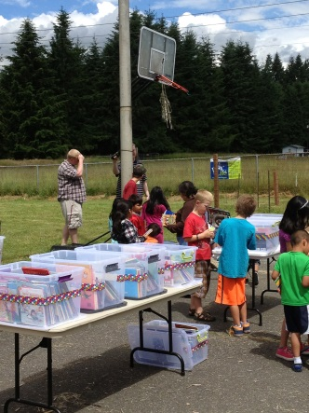
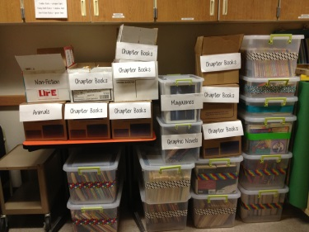
As a result, the next year (summer 2013), I decided to go to the students (alas, the whole if they won’t come to me, I will go to them theory). The previous school year, our school district had started a summer meals program for students who needed lunch during summer vacation. The school district was expanding to include a mobile version to be able to hit the outlying areas of need and I decided to tag along with it. I wrote a grant to our local foundation who generously funded $1500 for me to purchase books, tubs, and gas for me to be able to take books to students. I was able to use an old school district van and each week we loaded about 30 bins of books into the van and I went to three different locations, set up folding tables, and put the books out for students to browse through and take. I had the help of many volunteers as well as my family and, in retrospect, I about killed all of my volunteers with the lifting and the heat. We did A LOT of sweating as we hauled books in and out of the van at the different stops each week. At the end of the summer, I realized that if I was going to continue this, I had to find a better way.
© Snohomish Book Cafe
© Snohomish Book Cafe
Setting Up Tables With Book Bins
Getting Books Ready For Distribution

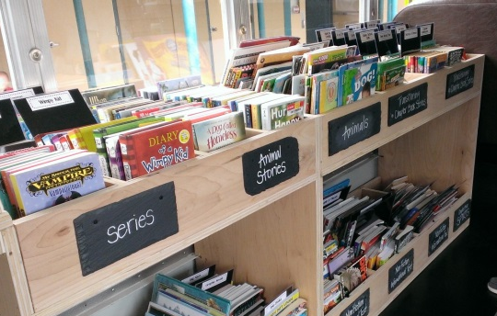
The solution came from the result of a speech I did during our education foundation’s annual fundraising auction. As I told the crowd about the success of our summer reading adventure thanks to the foundation’s generous grant, the technology director for our school district heard the spiel and jumped on board. He helped me to write another grant, adding more money for technology, and providing me with the networking opportunities for an old school bus. Fast forward to this summer (summer 2014) and we are doing 4 stops each week in a small bus that was going to be surplussed but the school district allowed me to use it for the book mobile. One of my amazing teacher’s (Ed Kowalski) is a phenomenal wood worker and has built many of our teachers a wooden shelf/bin combination that allows the students to flip through the books, similar to those of us who are old enough to remember going to a record store and browsing through albums (totally dating myself on this). Ed built the bins for the inside of the bus as well as a desk for the technology department to be able to add laptops in the future for access to downloading ebooks. The great part of this system that Ed designed is that today’s students are growing up in such a graphic-sophisticated world and with the books set up this way, they can see the covers easily.
© Snohomish Book Cafe
Fabulous Bins Built By Ed Kowalski

The response from the community has been tremendous. I have done a couple of informal spiels at various parent organizations and families have been very generous with donating their used books. It has been a great recycling program as kids outgrow their books… I know as a parent, I am always going through my kids’ clothes, toys, and books, trying to weed out things they do not use anymore. Being able to hand off books in great shape to other kids has hit a nerve with our community and the donations keep coming in. We have hundreds of books to choose from as well as new ones that I have purchased with grant monies.

How does it work? (Do kids get to keep the books, or do they have to return them?)

The books are for the students to keep or return… it is up to them. If they love the book… they can keep it. If it was just a one-time read, they can then return it for someone else to read. The goal is to get books into the homes…research is telling us that the reason some kids from homes of poverty do not read is because they do not own books… this is an attempt to alleviate this problem.

Some people have given me the comment of “Isn’t that what the public library is for? Why don’t these kids just go to the public library?” and yes, that is a great point. But our reality is that these students simply do not go to the public library. Whether it be because of transportation or because of having to fill out paperwork (which then leaves a paper trail) or because the family does not see the value of the public library… I do not know. But I do know that most of our kids do not have a public library card… and sadly the public library is only 6 blocks from our elementary school. And our public library is fabulous…there is tremendous outreach into the schools. But for whatever reason, our students do not seem to go to the public library on their own.

How is your project funded/where do the books come from?

The Snohomish Education Foundation (http://www.snoed.org/) is our local education foundation. The SEF has a classroom grant process that they present yearly to the district staff. I have written many grants over the years and they have always been very generous. From books to Kindles to hot cocoa machines to this bookmobile, the SEF has been very supportive of my efforts to get my students reading.

In term of cost…everyone wants to know how much this project costs. The first year I wrote the grant it was for $1500. That covered tubs/bins for books, signage, gas, and books. Then this year I wrote a grant for $5000. The bus was donated and money has gone to pay for floor coverings, wood, signage, decorations, books, and gas. I have spent about $1000 on the shelving and interior and about $1000 on books. I am budgeting about $1000 for gas and the rest of the money is going to the technology that will eventually be placed on the bus. The tech director is looking at adding a wifi connection and devices to allow us to assist the students with downloading ebooks from our collection.

My time has been donated. It is more than worth it to me. Yes, it has taken over my life and my summer vacations… but I would much rather be a part of the solution than keep complaining about the problem of kids reading during summer vacation.

Can you describe the overall look of your bus.

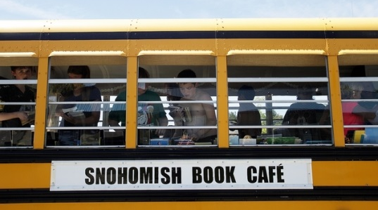
This book mobile has been a collaborative effort! Like I mentioned, Ed Kowalski built the interior bins. My husband, Tim Granger, helped me build a ramp out the back, put down some flooring to hide the holes where the bus seats where, as well as tackle the signage on the outside of the bus. He is the one who talked me off of the ledge when I realized late one night that the expensive magnetic signage I ordered and painstakingly had cut & adhered vinyl letters to was not a total loss when I went to go attach the sign to the bus… and the sign fell flat on the ground. Who knew that the sides of a school bus were not magnetic?!? UGH! My kids, a 14 year old boy and 10 year old girl, have spent a ton of time helping us get the bus ready as well as helping to load books every week. I have the best family!
© Snohomish Book Cafe

My friend and former colleague, Jamie Rufert, helped me with the interior, decorating it with café awnings and book page crafts. My educational assistant, Karen Vaule, painstakingly sewed the book page garland together when I decided to divorce my sewing machine late one evening.

I had been parking the bus at the back of my school when I was working on it, in and out of classes and students. My BD teacher, Dave Martinson, and his assistants Bibi Penland & Michelle Somerville, somehow snuck out and painted the tire rims and running boards on the bus when I was busy with students... it was a total surprise! They looked amazing! And my assistant secretary, Penny Kendrick, secretly ordered the pink eyelashes for the bus. They are darling!

I kept everything in a fairly neutral color scheme with book pages, burlap, and chalkboards. I knew I did not want it to be too cutesy in terms of primary colors or book characters because I did not want to scare away my older students. If this was a “little kid’’ thing, they wouldn’t come near it. Needless to say, that hasn’t been an issue. I cannot seem to keep enough copies of The Fault in Our Stars or Divergent stocked for our young-adult readers.

How do you decide what books to stock?

My goal is to stock it with what kids will read… I do not push anything other than simply reading for reading’s sake. Do you want to read creepy vampire stories? Go for it! Teen romance novels? They are yours! Dirt-biking magazines? Go for it! Blogs? Sure! Anything and everything is fair game. Both activity books and Pokémon books tend to fly off the shelves as well as anything that is humor related, from Garfield to Diary of a Wimpy Kid.

In terms of the types of books we have on the book bus, we have everything from board books to picture books to chapter books to graphic novels, young-adult books, and magazines. A lot depends on what is donated and I spent the grant $ on high-interest things that kids want like Diary of a Wimpy Kid books and the I Survived books. If they will read it, I will try to get it for them. With the recent World Cup, we went through soccer books like they were water.

Do you do any kind of readers advisory with the kids you reach, asking them about books you think they’ll like?

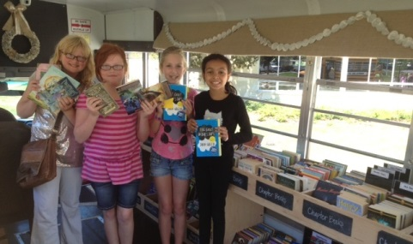
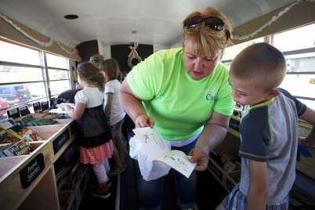
Absolutely! And I think that is part of the key to the success. Talking with the kids and listening to what they want and (when possible) making that happen… it shows that I value what the kids are telling me and how I value them as readers. As I come across books in all of the donation piles, I add sticky notes with names on it and give it to them the next week. It helps that 3 of my 4 stops are neighborhoods of my own students, so I know them by name and what they are interested in reading. This is my second year getting to know the students at a trailer park that go to a different elementary school and I am getting to know their needs/wants as well. I almost got tackled for the soccer books last week.
© Rachel Belle/KIRO Radio
© Ian Terry/Everett Herald

What “routes” do you take/how do you decide where to go?

I knew some of the places I wanted to hit because I knew the families in our community that were in need. And I knew that the mobile meal program was hitting the areas of high need. When I originally wrote the grant two years ago, I had only students from my school and our feeder schools (both primary school and middle school) in mind. But at the last minute, one of the TOSAs (Teacher on Special Assignment) in our district approached me and asked if I would consider going to another trailer park on the other end of town. This trailer park was very isolated and very in need of books. How could I say no? So each week I drive the bus to two trailer parks, our local aquatics center which is in the middle of town, and the Boys & Girls Club. All of these locations receive lunches as well from the summer meals program.

Do you think you’ll keep going with this in the future? If so, do you want to change/improve anything for future summers?
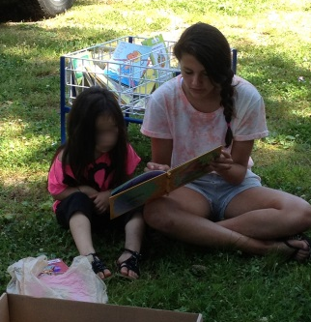
Great question! In a perfect world, I would love for this to become a Title program. Dr. Richard Allington’s work examines the impact of summer reading on student achievement and one of the points he makes is the fact that Title programs have shown an impact on achievement 9 months of the school year. But what about the other 3 months? Spending the funding to help support a child’s language development year-round could lead to a significant increase in academic achievement. The funding during the summer months would not be pushing an academic agenda…it would be creating an environment that fosters reading and language development. That, to me, is an important distinction.
© Megan Sloan

What would it entail? Still living in my perfect dream world, I think $3000 each year would cover the cost of this program. Breaking that down, if this program were to pay for a teacher or a teacher-librarian to drive, distribute the books, and then restock the bus each week, that would cost around $1000. Add in another $1000 for gas and another $1000 for new books on hot topics that the students are reading.

What would I improve? Hmmm, air conditioning on the bus would be lovely.

And one other thing I want to add…

I get a lot of people asking me how I assess if this program is effective. My goal has never been to have anything formal… the goal is to get kids to see that reading is something that doesn’t just happen at school. Being a reader is a 24/7/365 thing that can happen anywhere at any time. Instilling good reading habits and offering up fun, engaging books to replace the thought that reading is only a “school thing” has been my goal.

First and foremost, I do not count books each week nor do kids have to check them out. I would go totally bonkers if I had to have that accountability. All the funds to purchase things have been grant monies and it was very clear in the grant application process that these materials were to be considered “consumables” and not be inventoried. None of these books are library books or anything that was purchased with tax payer money.

In terms of “data”, I have also kept this very informal. In the fall of 2013, we looked at test scores from 10 students that were struggling readers and had visited the book mobile over the summer. Half of them had scores that improved in the September assessment from the June assessment by at least half a grade level; half did not. I conferenced with each of those 10 kids, asking them if they had read the books they had received over the summer and why/why not they thought their reading scores had improved. The students that did not improve in their reading scores or went backwards fully admitted to not reading over summer vacation. They were somewhat sheepish about having taken books yet not reading them. The students that did improve their reading scores from June to September either read over summer vacation or attended summer academy (a hands-on summer school our district offers scholarships to). All ten students were consistent in what they reported with what the research shows regarding summer reading and the summer slide.

Okay… I lied… one more thing…

Links & contact info:

- https://www.facebook.com/snohomish.bookcafe
- Snohomish Book Café explanation: https://www.smore.com/4hubh
- How people can donate: https://www.smore.com/uut97
- Got Books?!? https://www.smore.com/2et7g
- School Library Journal article: http://www.slj.com/2014/07/librarians/school-librarian-fights-summer-slide-with-school-bus-turned-bookmobile/#_
- Everett Herald: http://www.heraldnet.com/article/20140717/NEWS01/140719233
- King 5: http://www.king5.com/news/education/Librarian-rolls-out-free-books-to-kids-264484351.html
- KIRO’s Rachel Belle… love her… a 3 min segment she aired: http://mynorthwest.com/874/2557379/Book-Cafe-is-a-LibraryOnWheels-For-Snohomish-Kids-on-Summer-Vacation

